ART mapping: Year 3 Natural Disasters March/April 2018-19
Skills | Activity | Resources | Techniques | Examples
Drawing | Draw a response to a Natural disaster  Draw using various tools.  Use a picture of a natural disaster to extend details. | Paper and pencils. 4B or 8B  Large paper: pencils and drawing pens.  Pictures to discuss PP  Chalking | Observational work  Use of line and shading  Extending drawing | 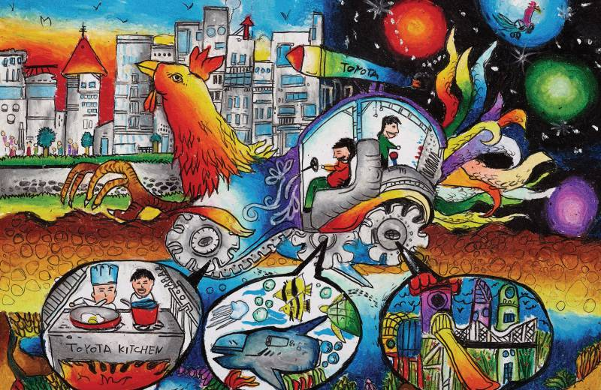
Painting | Painting in response to a disaster.  Using collage and montage to enhance expression.  Using thick paint as a response.  Using mixed media to respond to prevention of disasters or the fall out. | Paper, water colour paints, brushes,  Black and white paints (Guernica) | Water colour technique, Working small. Draw with permanent pen then water colour.  Large painting (shared?) to express emotion. | 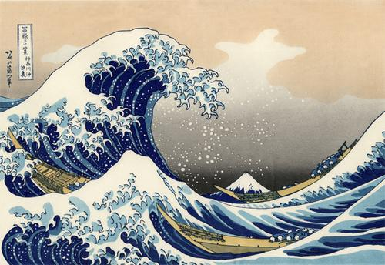
Collage | See painting | Paper, blue fabrics with texture, bright coloured felt, red, orange, yellow,  Card, paper, material etc | Cut and stick, choosing colours in compliment  Making layers and overlaps | 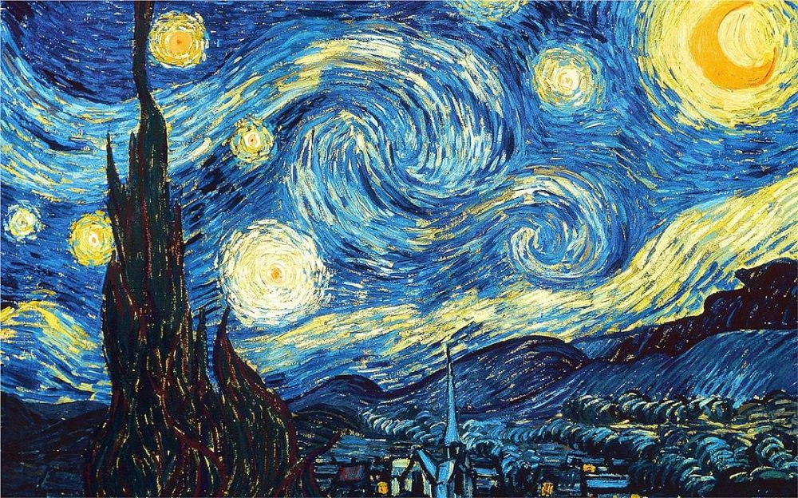
Printing | Using impressions to enhance an effect on a painting. | Potatoes, paper, printing ink, trays  Black paper, white paint, hands. | Stamp making designs, using clay or potato or hands. | 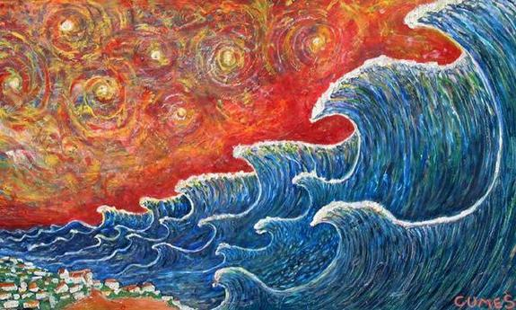
Textiles | Using textiles as collage.  Weaving a textile for a purpose.  Using dye and pens on fabric for effect. |  | Sewing, ordering,  Painting techniques on fabric – pens, paints, crayons.  Using selected fabrics for effect. | 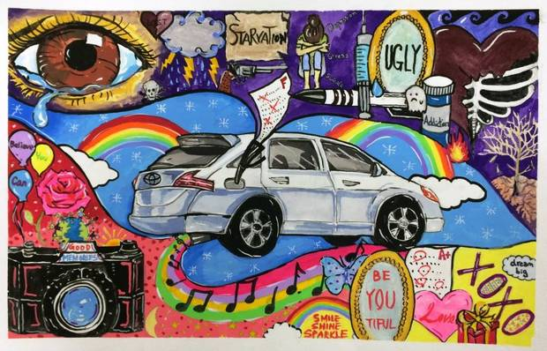
Sculpture | Plan and investigate making a sculptural phenomenon to show meaning and shock in a disaster happening. | Wire, ModRoc, tissue paper, white paper, white junk items.  Salt dough, paper mache, | Use ModRoc, wire building techniques, gluing.  Paper mache or other modelling medium.  Salt dough | 