ART mapping: Year 4 INVENTIONS: Musical instruments January/February 2019
Skills | Activity | Resources | Techniques | Examples
Drawing | Observational drawings of musical instruments using various media.  Chalk and charcoal drawing  Thick marker pens on sugar paper.  Colour pens for drawing | Pens, pencils, crayons, etc  A selection for choice  Black/white pens and paper  Chalk/charcoal  Variety of paper colours  Felt pens/oil pastels | Use of line, shape, space, tone, shade.  Observe and draw  Accuracy of looking and recording.  Creating atmosphere | 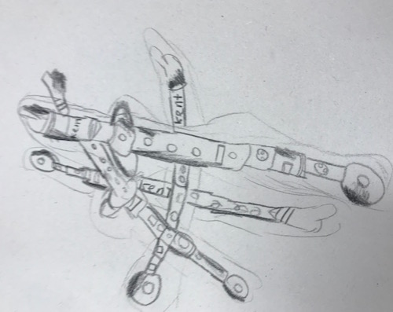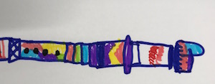
Painting | Not applicable
Collage | This topic is majoring in collage.  Focus: George Braque Pablo Picasso  Produce a major ARTWORK for a Private view display... | Large cream card A2  Various colours of brown and cream papers, textures, newsprint, maps, wrapping paper, tissue, measuring tape, art straws, etc. | Arrange papers and collage materials on your paper/card.  Stick down as required | 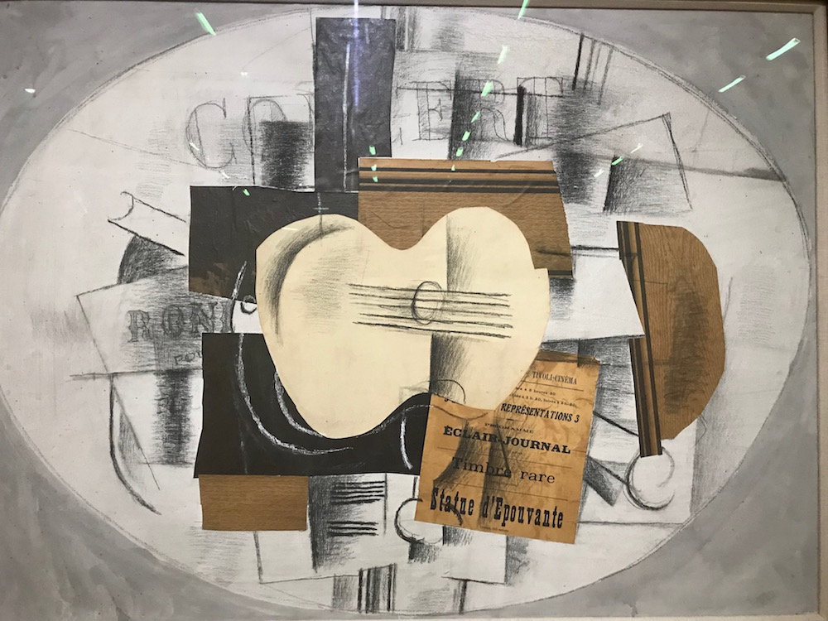
Printing | Not applicable |  | Make a bespoke Art book for each child’s work. Arrange for the Private view....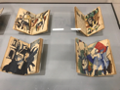
Textiles | Not applicable
Sculpture | Make a small pinch pot using clay.  Use modelling clay to make a design with a musical motif used in our drawings.  Make a card sculpture of a musical instrument. | Clay  Paints  Nail varnish  Brown, black and dark blue card, scissors, glue, string. | Manipulating and designing  Using drawings to inform sculpture.  Collaboration in design and finish. Using appropriate colours and tones.  Sculpte using card.... | 