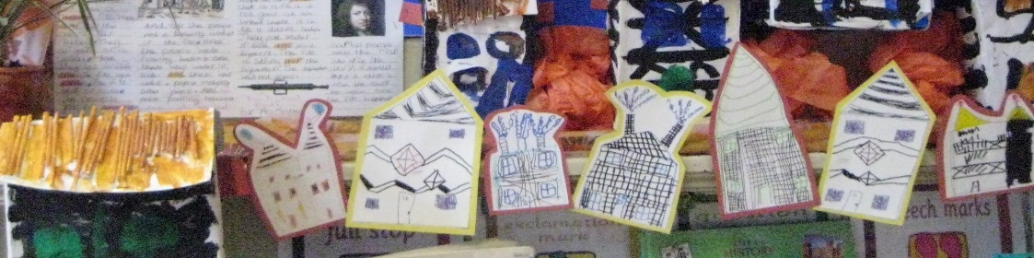
The Classroom learning environment

Shirley Sides


