Heart of ART
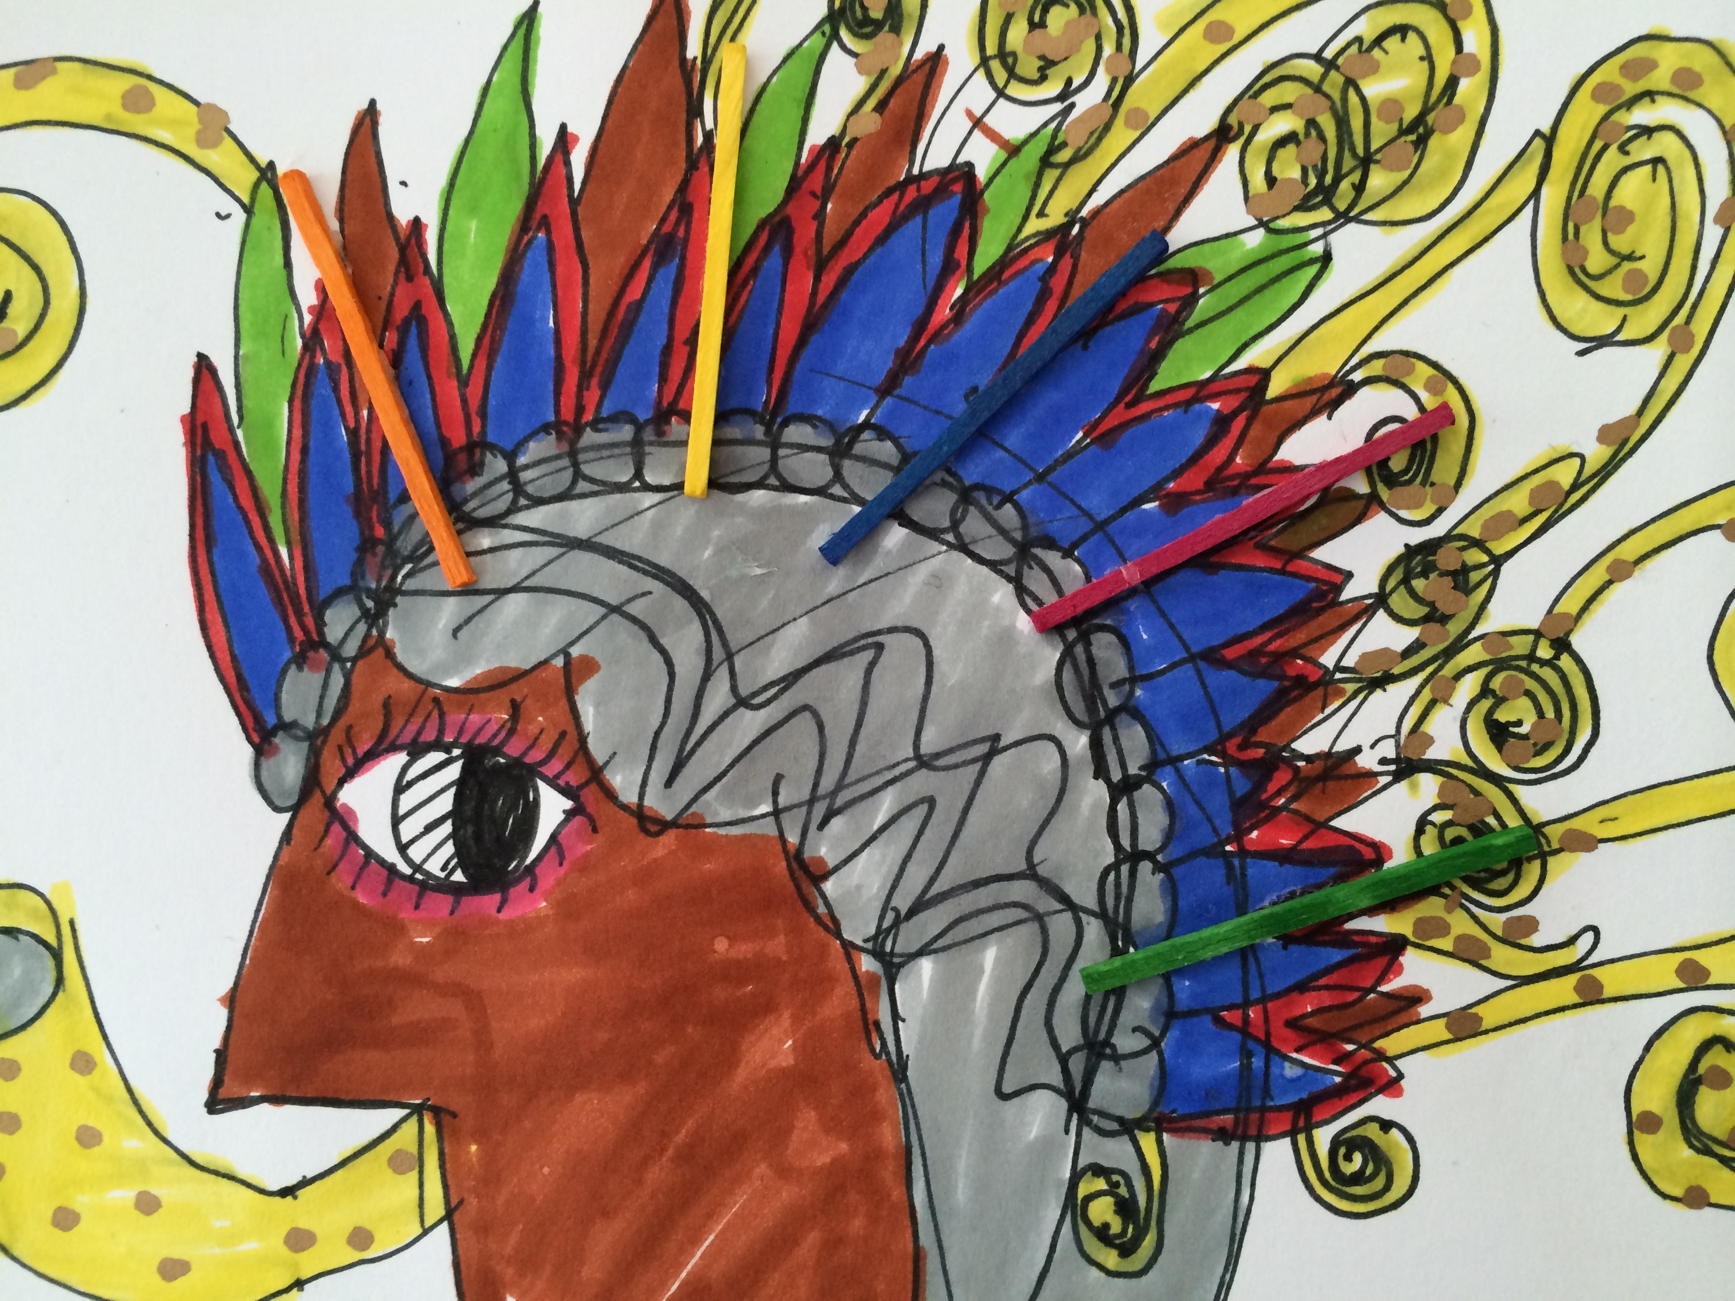
Care of ART resources
Shirley Sides

