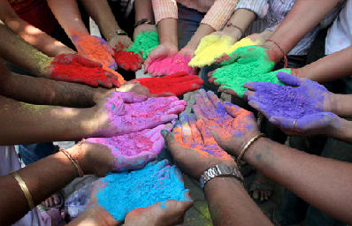
Care of hands:
This is the most important bit…
Cleaning Art equipment is quite harsh of hands, so it is good to wear plastic gloves to clean very messy things.
Use a good hand cream afterwards, as the effects of paint and inks, etc. as very drying on the skin.

WHY?
Buying resources is an expensive business, and we still pay tax, even though we are a school. It is important that we make what we have last as long as possible, but also using them as much as possible…
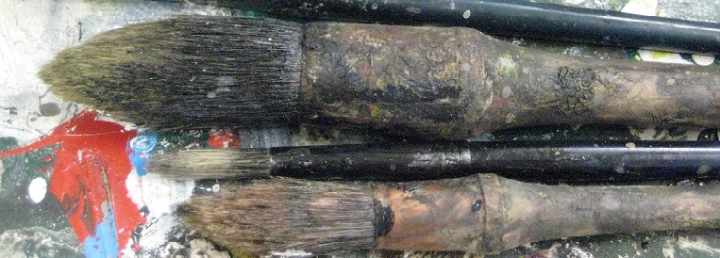
Also, it is important that children understand that what we are provided with, costs money, and to learn to use items and materials, in a responsible and economically astute way. This is another way of using our creativity and ingenuity.
Our world is being destroyed by the relentless use and over-use of resources, and the constant waste and irresponsible way we all think about what we have. Our resources will last a long time, if we are just a little more careful and responsible about how we use them.
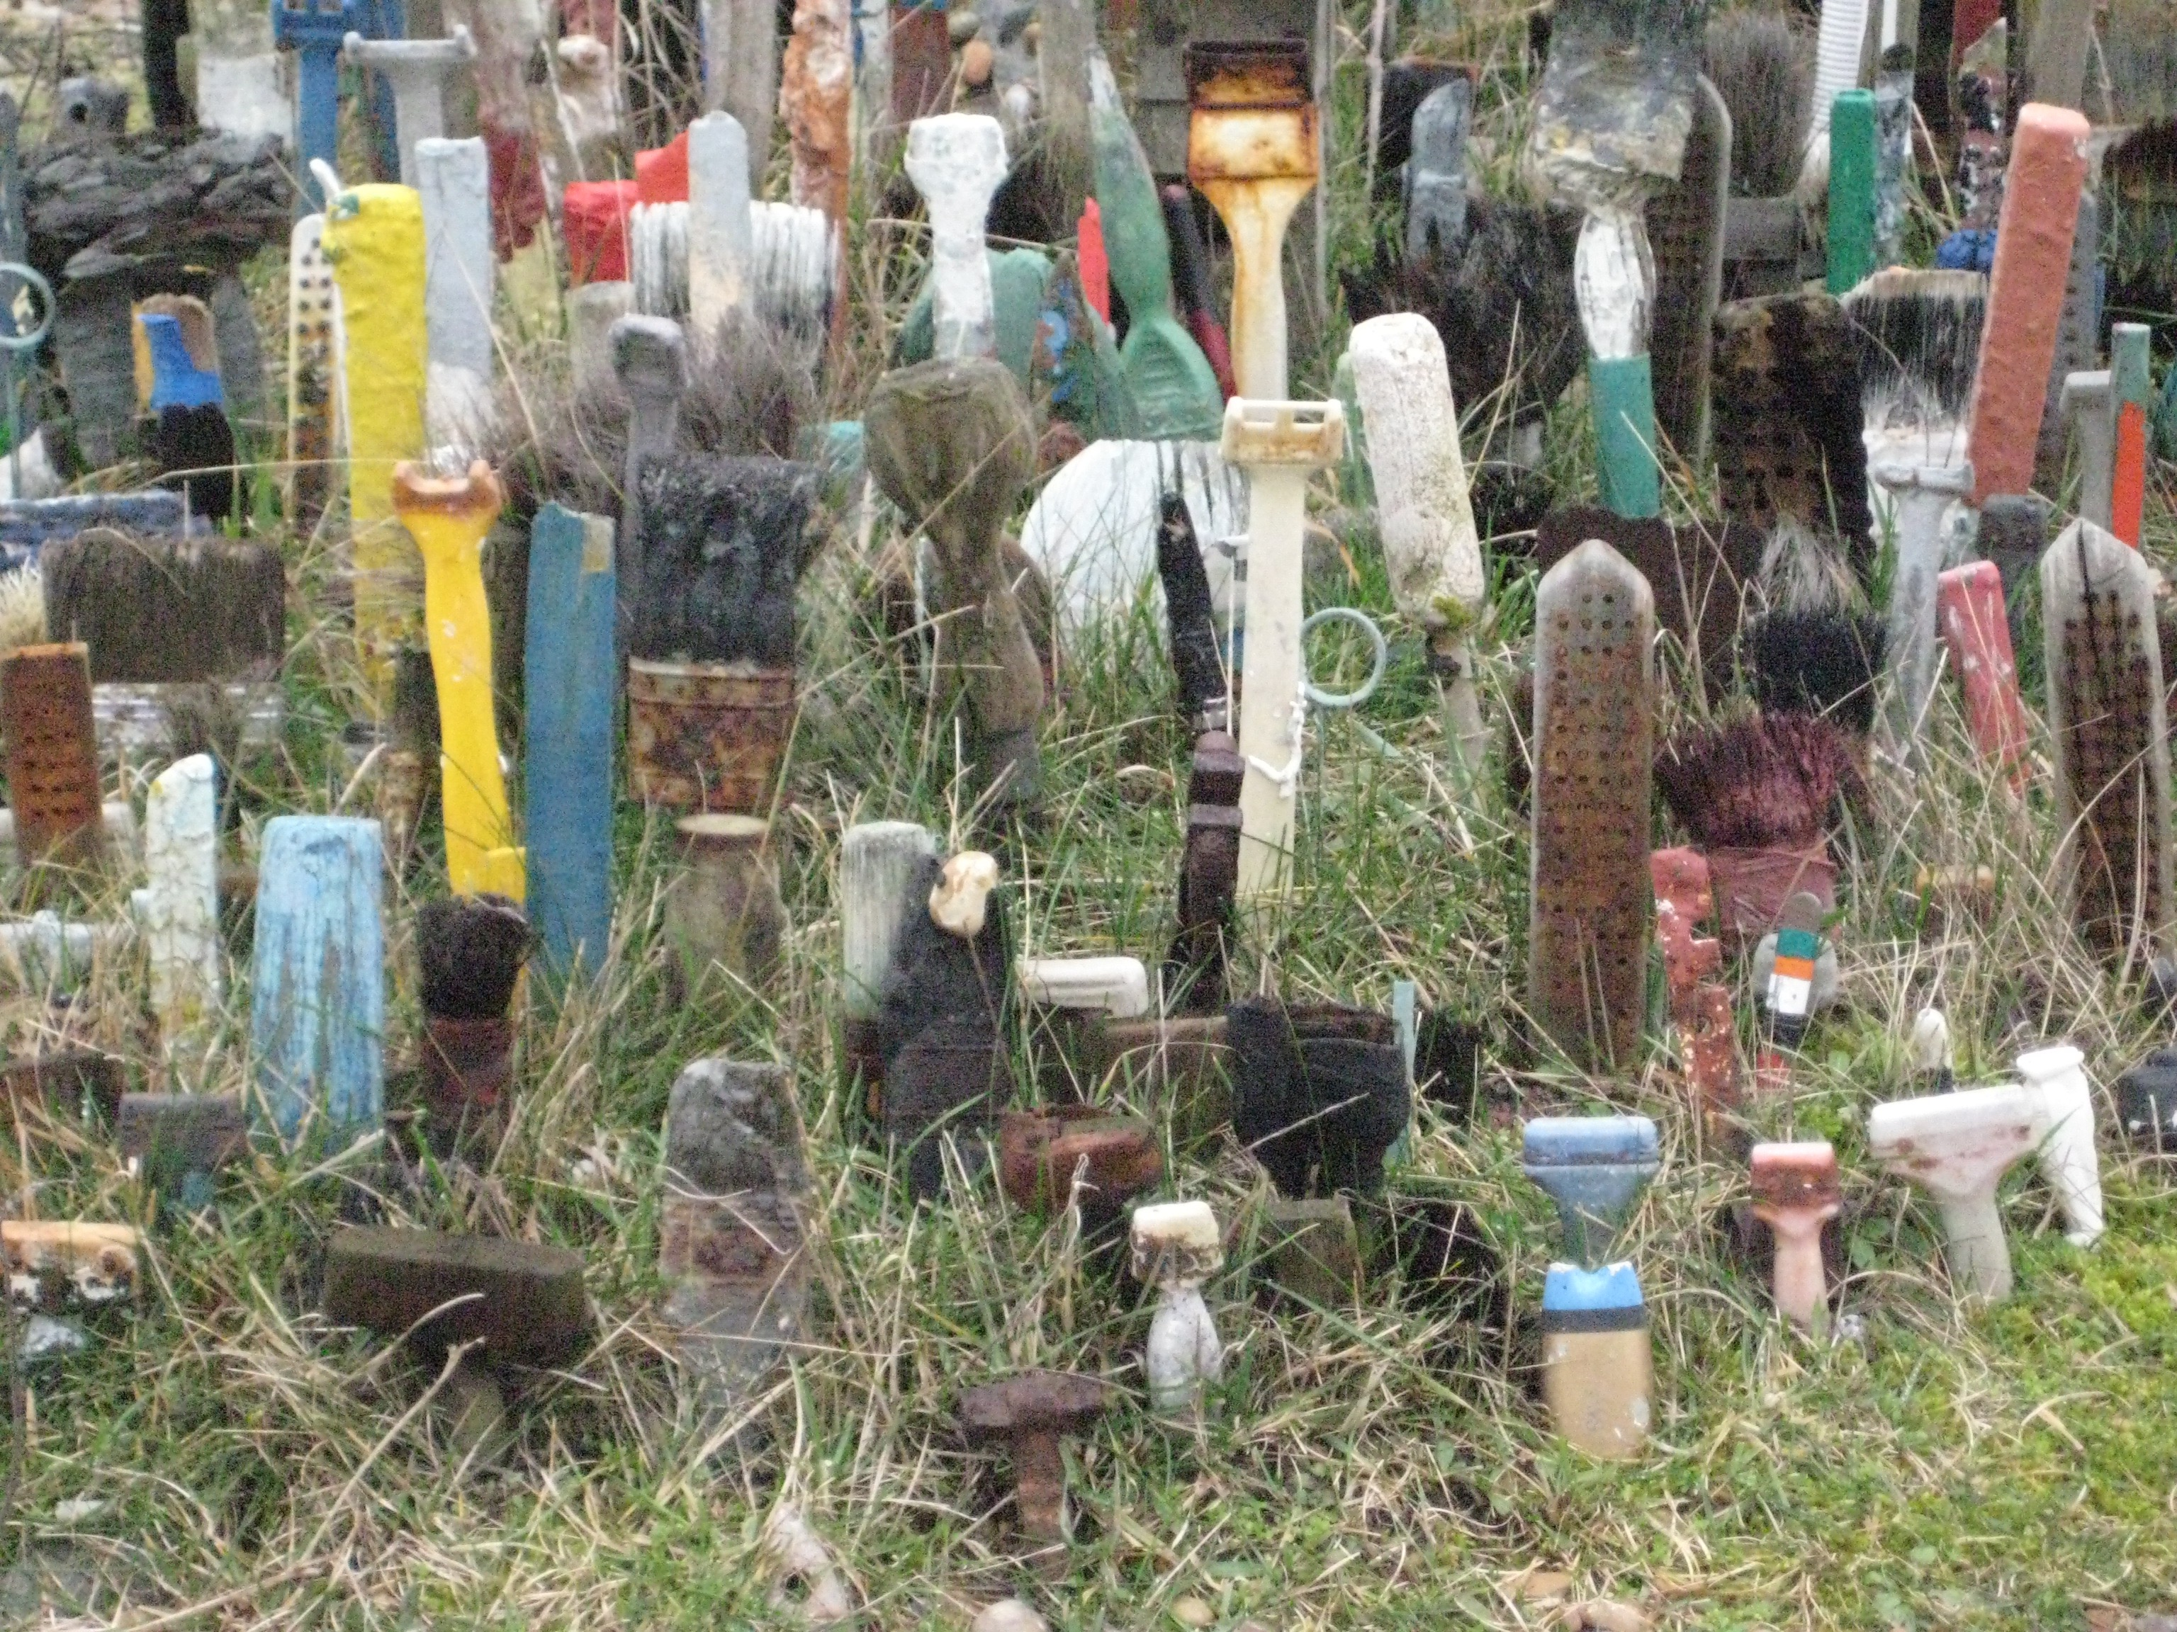
Even tools and materials that look past their best, can be used effectively in another context.
It is too easy to throw out paper and disposable resources, but by just keeping bits and pieces, we can use them on other occasions.
Children can collect plastic containers to store the class materials, which makes them a part of the sense of responsibility.

Glue:
Lids must go back on the glue, and children have to know why. The glue stick seems to be used a lot, but we could also use PVA liquid glue, as there is quite a lot of this.
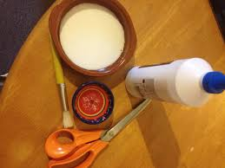
We could save small jars, face cream jars, etc, and could keep this with the lids on. It is good for the children to know how to use the PVA glue neatly and cleanly, and to wash up and store the glue sticks for another time.
Sequins, feathers, pom-poms, pipe-cleaners:
We may be able to purchase these things, but often we are not able. It is good to collect junk, bits-and-pieces, and keep collections of things for collage and junk modelling. Collect buttons, snap fasteners, zips, ribbon, lace, off-cuts, etc.
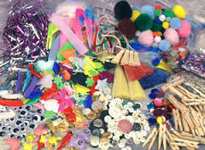

WHAT?
Some resources can be used again and again, if we care for them. Looking after brushes, tools, pens, glue sticks, etc, means we can buy other things to add to the variety of materials offered to the children.
Many resources are expendable, and get used up quickly. But even these can last longer, if we cut down the amount of scrap we throw away. Paper bits can be saved in jars for other activities; sequins can be put back in the jars; cotton wool, shiny papers, sticks, shells, etc, can all be saved for other occasions.
It is a good idea to start saving bits and pieces and making your own collection, for Art work in your classroom. You can get family members involved and people you know, to keep things that could be used for collage, decoration and embellishments.
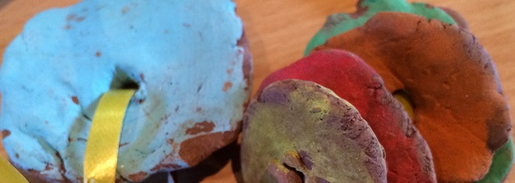
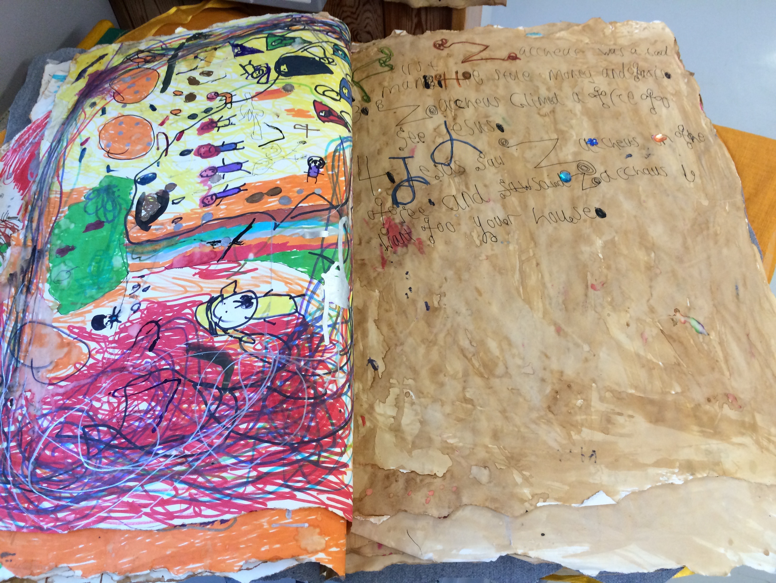
Using scrap materials is a good way to get variety, and make Artworks that are unusual and individual.
Scrap papers are great, and everyone has them! Newspapers, cellophane, foil wrapping, wrapping paper, etc. Some companies will give schools paper that they do not use and are throwing out.
Cardboard materials are good basis for 3D work.
The rollers especially will be less effective, and make it difficult to use and carry out process tasks, if they get gummed up with printing inks.
Once the children have learned the process, they can clean up very effectively. Younger classes may need help, as the ink is quite messy.
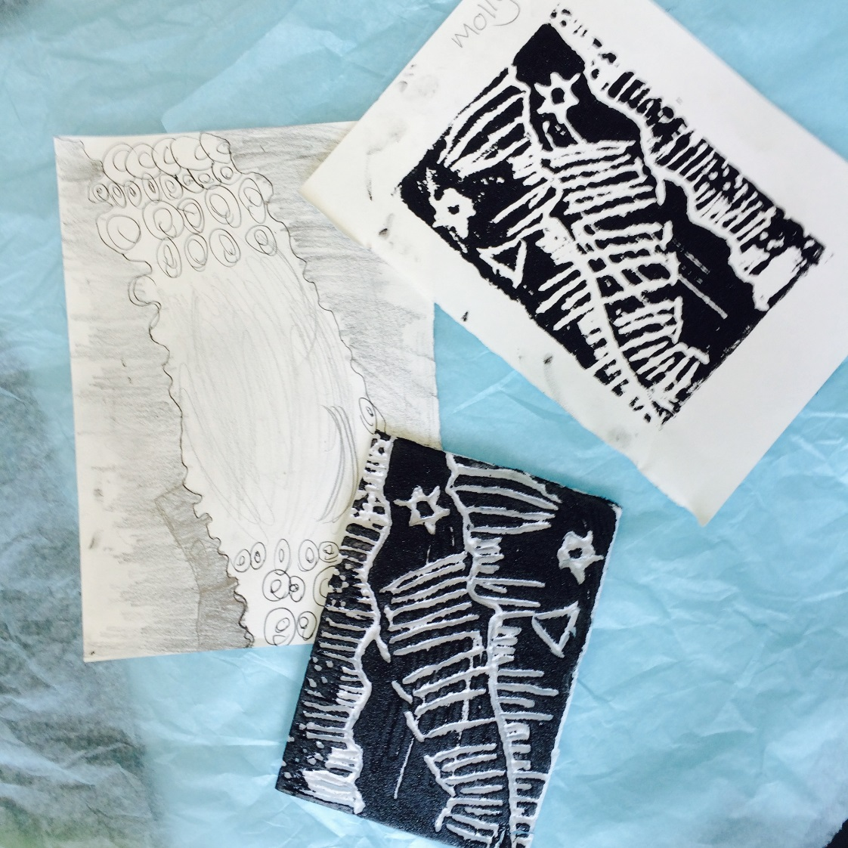

making their own. Charity shops are great places for finding off-cuts of fabric and yarns.
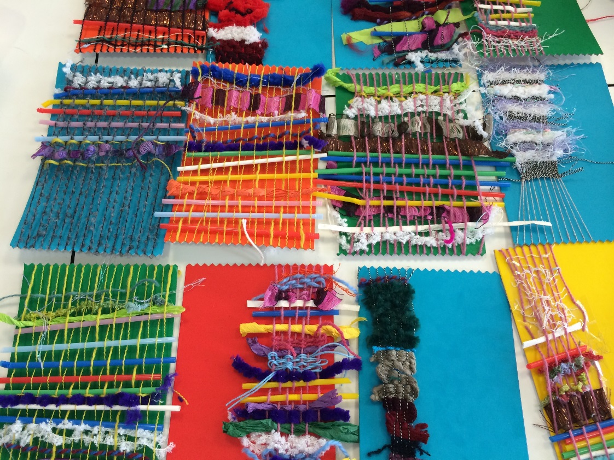

Printing:
After the printing activity is over, the rollers and trays, must be properly cleaned straight away, and not left, as the thick consistency of the printing ink, becomes impacted on the equipment. It is best to use plastic gloves, as it stains the hands if there is a lot to clean up.
WHEN?
After every Art lesson, the tidy-up time is the time to teach each other how to put things away safely and carefully, with an eye on the next time. Save rather than dump.
The children will get the idea quite quickly, and soon be coming up with their own ideas about keeping things tidy and convenient to use.
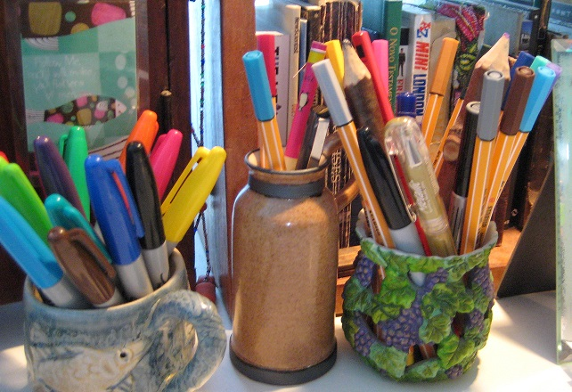

Once the children get the idea, they will be looking for stuff to save, and become more efficient at tidying up properly and carefully.
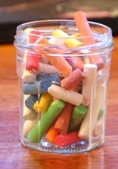

Fabric, yarn, felt, etc:
It is a good idea to collect these kinds of resources, as they are silly prices in the catalogue. Scraps from your own projects, or from friends and family, make good resources for Art lessons and projects. You can ask in shops for samples, or old swatches, or off-cuts from a tailor, or designer.
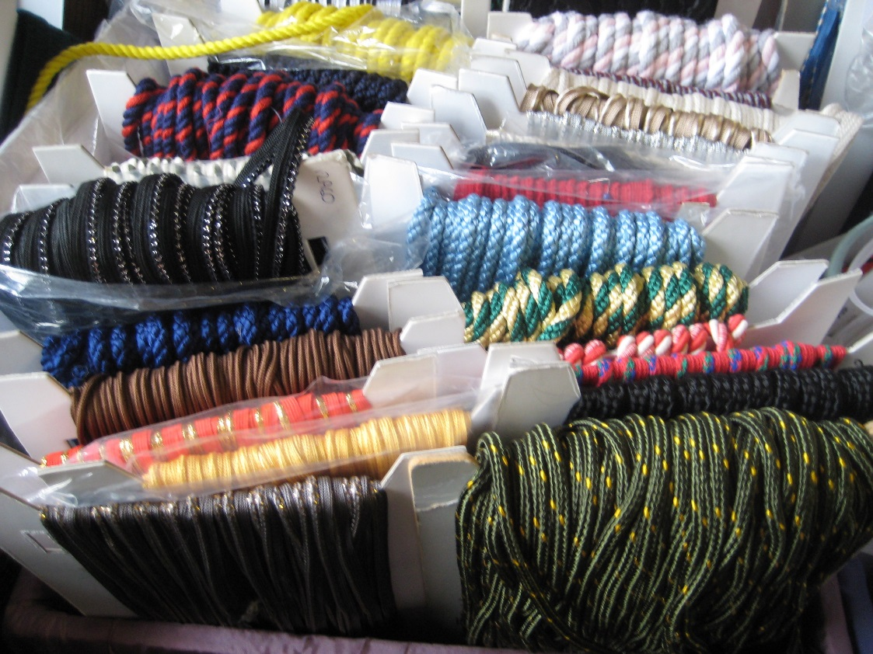
Collecting yearn, wool, threads and any fabric, can be used for weaving using pre-cut looms, or the children
At the end of the lesson, replace the plastic “skin” around what is left, and carefully put it in the outer bag. Twist the plastic at the neck of the bag as tightly as you can, and replace the wire, using a pair of pliars. This will keep well, if you have sealed it properly. It will not keep indefinitely, but will keep for some time.
When the clay is taken out of the bag, the children have to work quite quickly, as it dries out, especially with hot hands that evaporate the moisture.
Never leave the bag open..
Clay tools must also be washed and kept clean.
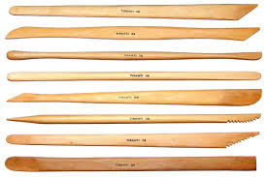
WHERE?
We can make collections and items and materials, in every classroom, so that we are all working together to preserve what we have and make our work more interesting and individualistic. Art is a time for using resources that you would like and in a way you would like, so it is reasonable to keep them looking good, working good, and lasting as long as possible.
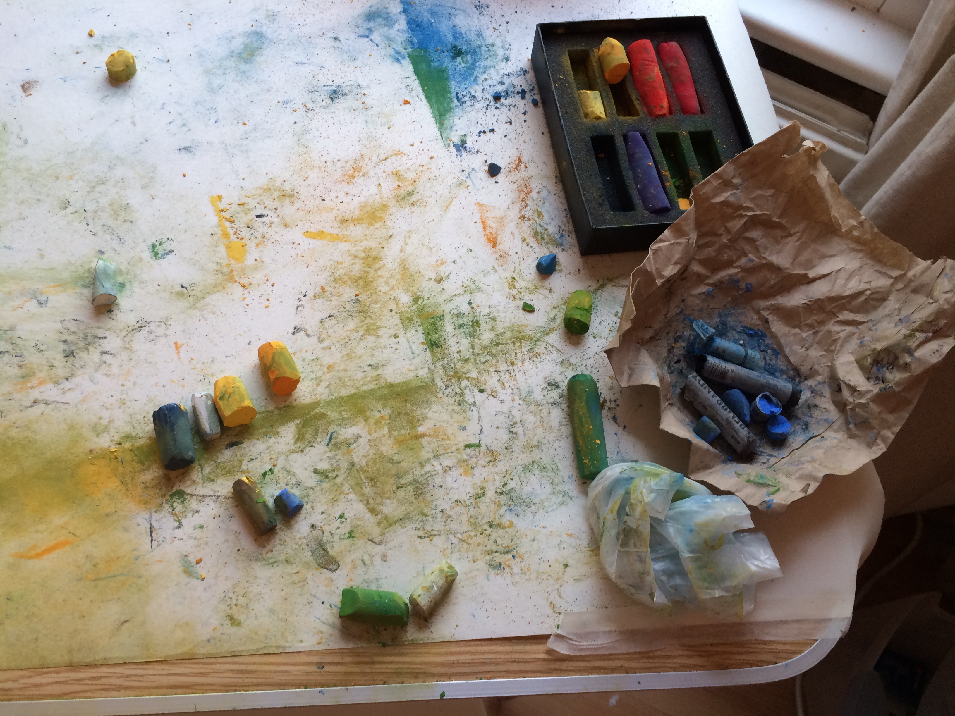

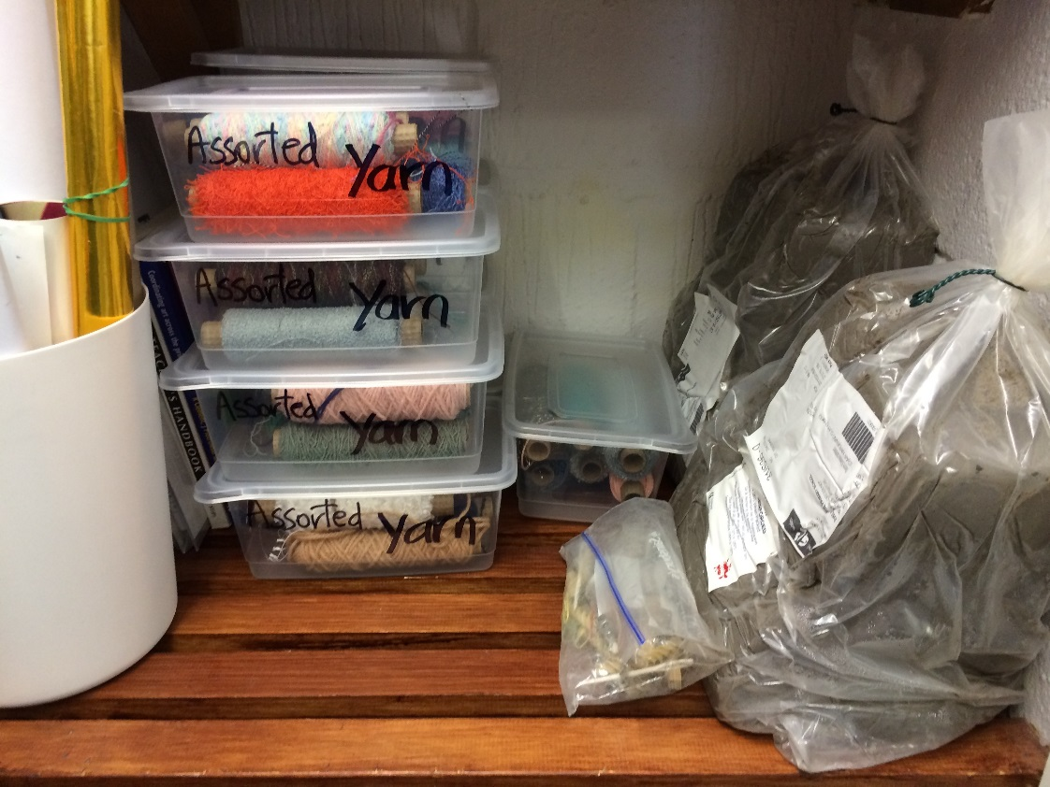

It is good that we make a “mess” and there is the liberty to experiment and try out new ideas. Art resources by their nature, are automatically more untidy looking, but that is good, we just need to make sure they keep working properly.
We want to look after our resources, but not be hung up on neat and tidy either. If we make a mess, it can be tidied up and left in a good condition for the next time.

Clay:
This is problematic stuff..! It is perfectly sealed (more or less) in the bag it comes in. Once you open it, it must be all used, or you must seal it up correctly so that it doesn’t go hard. It will go hard very quickly, and you cannot reverse the process. It you take the wire off the bag, keep it, to put back on. Take out what you need, and do not leave the bag open at all…!
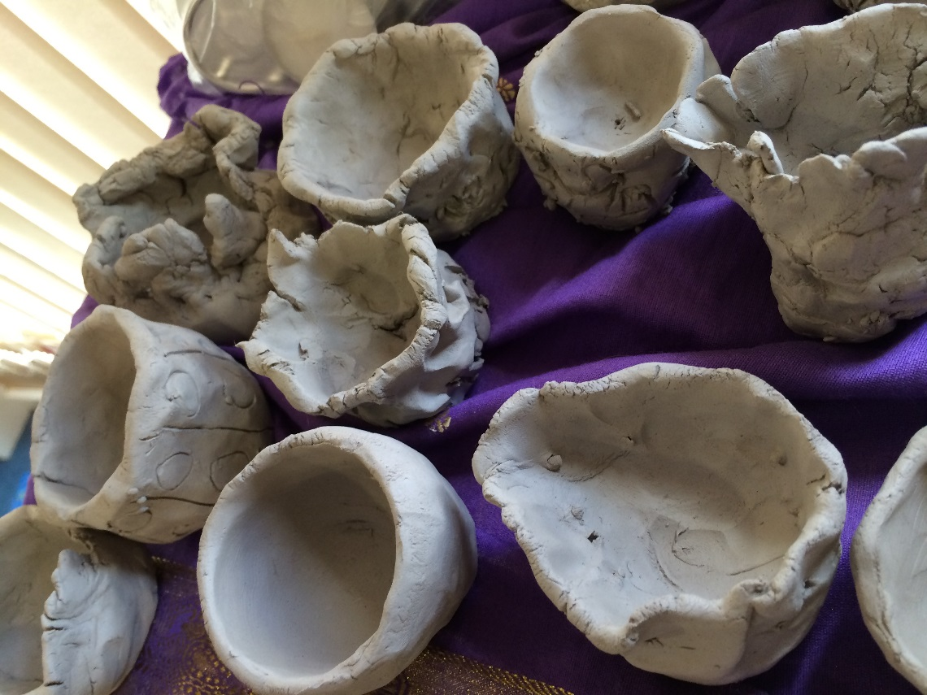

Similar pencils can be bunched together with an elastic band, or put in a food bag with a zip.
HB is a writing pencil
B 2B 4B 5B 6B 8B Soft drawing pencils. Getting progressively softer and with a darker effect.
H 2H 4H etc Hard pencils used for technical drawing. Not used in Art much…
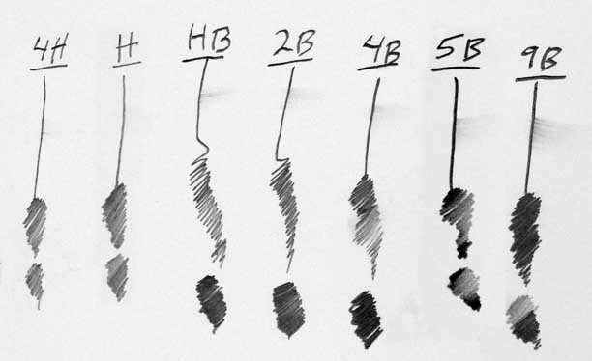
Try to dissuade children from sharpening both ends of the pencil… Manual sharpeners are preferred to electric ones.

HOW?
These are just a few ideas to get you started…
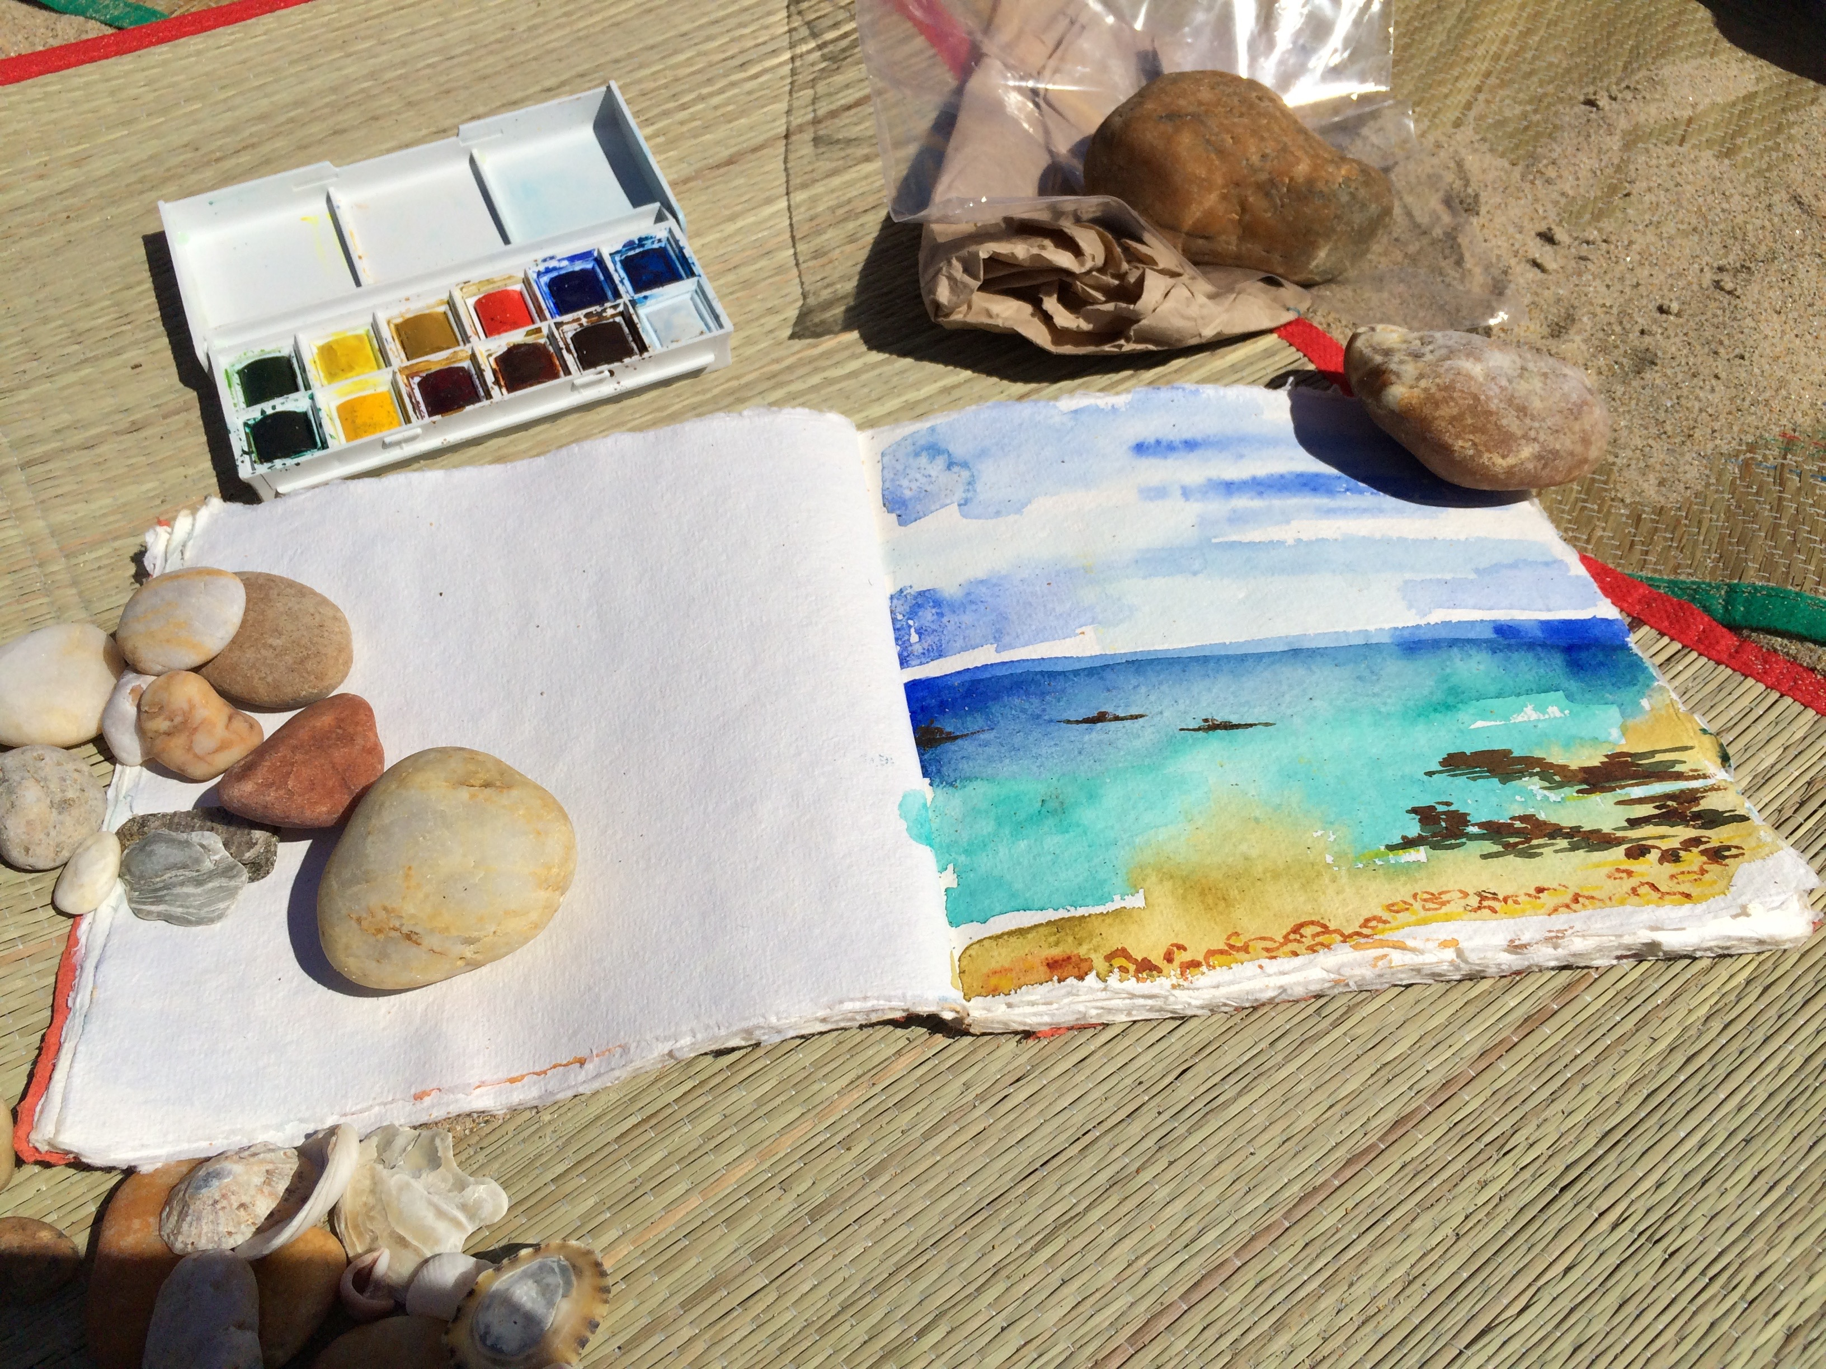
If you have any question, please ask.
Also any good ideas, SHARE..!

Paint brushes:
These should be cared for and washed well every time, as they are an expensive item on the resource bill. Children should be taught to wash them under the tap and gently squeeze the bristles, so the paint is washed out as much as possible. They should be left to dry flat on paper towel, or to drain in a pot, with the bristles facing upward.
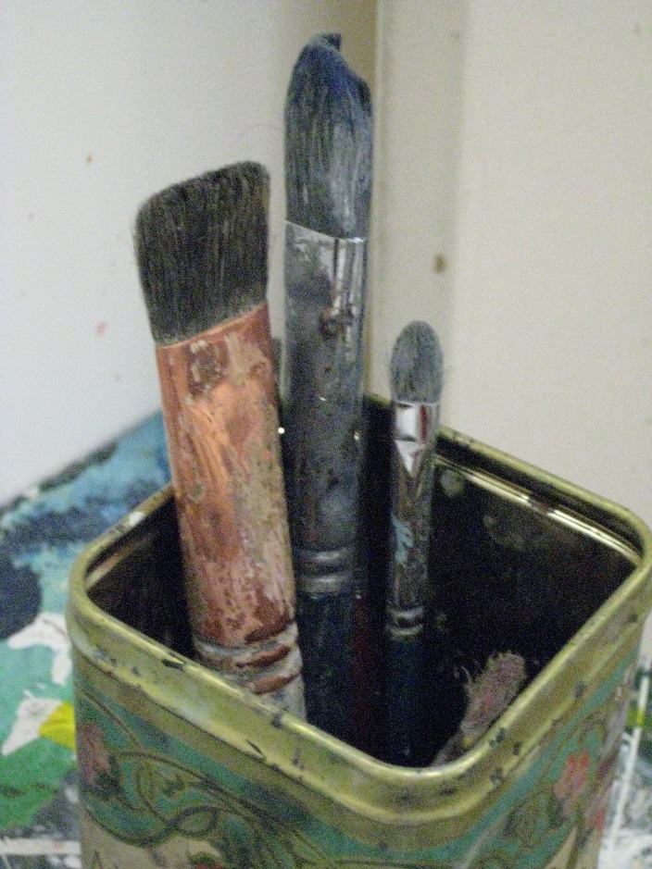
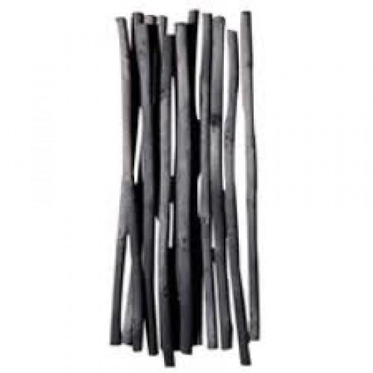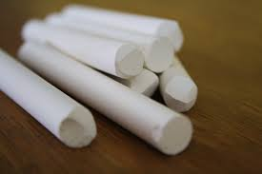

Drawing pencils:
These should be kept separate from the writing pencils… It is helpful to put them away sharpened and ready for the next time. They will not always need sharpening, and at times it is better to use the pencil bluntly. They are not to be used for other things, as they are specifically for Art work. Try to keep the B numbers separately…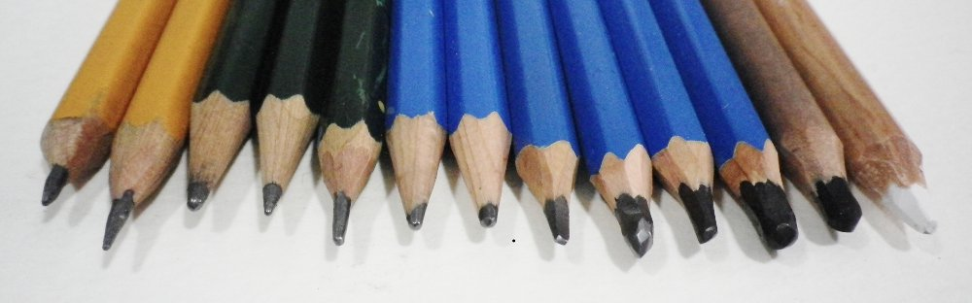
good. The pens do not need to be pushed down, but will work with gentle pressure.

Charcoal and chalk:
These should be shored separately, and the dust goes everywhere. Charcoal comes in a box with a tissue paper wrapping, and is best kept like this. Chalk can be kept in a box or jar. Both should be kept dry and out of damp atmospheres.
The finished work can be “fixed” with hairspray.
Children should paint with the brushes and not to “scrub” them on the paper, or push them down and twirl then against the paper, as this destroys their function. Also, they should not be left in water for long periods, as this ruins the bristles where they join to the handle.
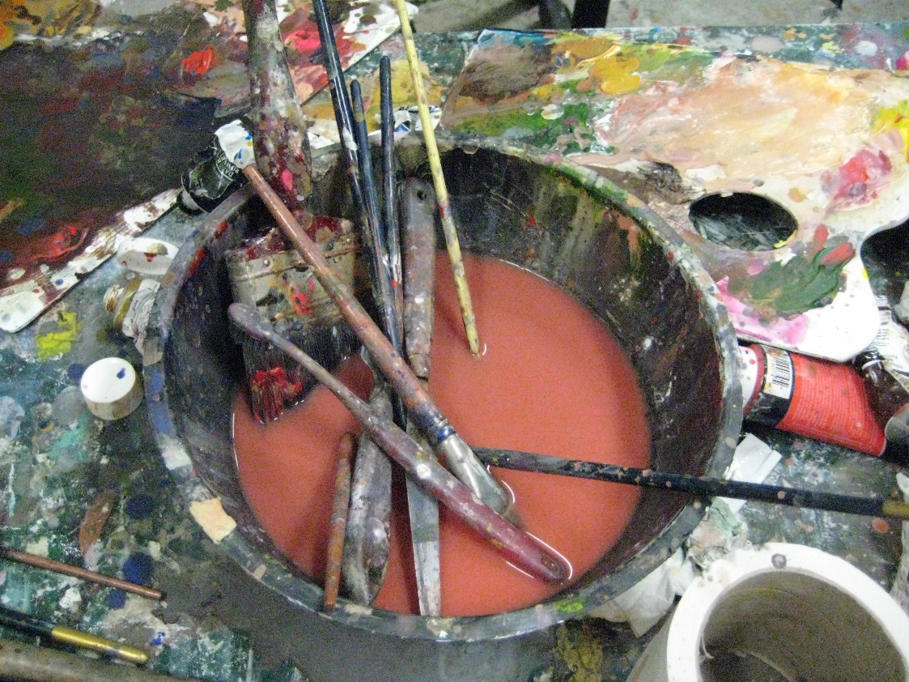
Brushes can be left to soak for a few hours, to loosen thick or dried in paint, but must be cleaned as quickly as possible. Leave them bristles down in a jar of clean, warm water, and rinse out quickly, and dry bristles up.

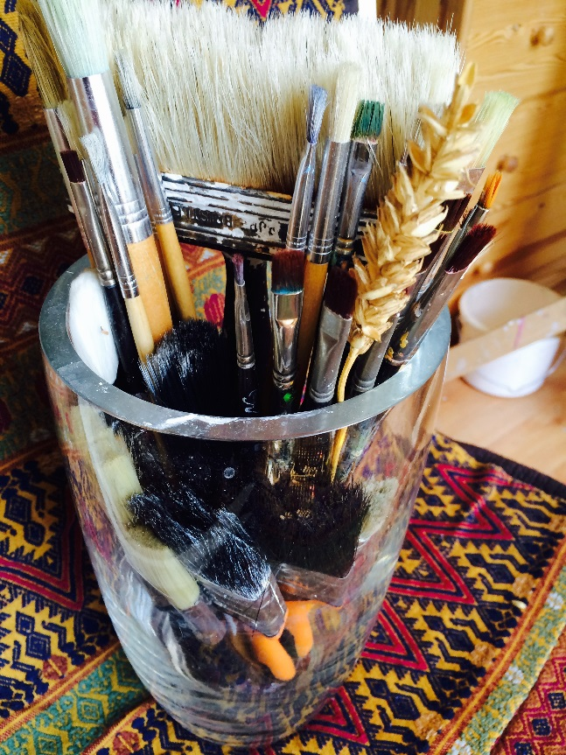

Brushes should never be thrown in the bin. Even when they are worn out, they can be recut and given a longer life..!
You could try making brushes, using fibres from cloth, or other kind of material. Experimenting is stimulating and helps us to appreciate how tools are made.

Drawing pens.
The greatest waste is leaving the pens without lids. They dry up overnight. Drawing pens are expensive and children need to be aware of that. We will need to check lids at the end of lessons, until children get the message. If the lids are left off and there is not enough to go around next time, and someone misses out.
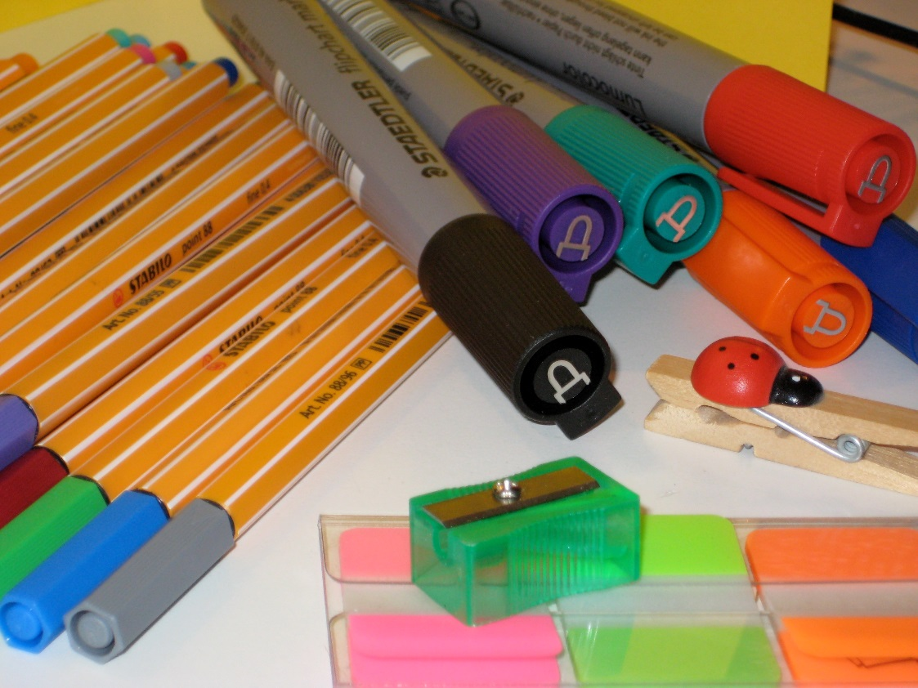
Using the pens, is also a skill to be learned. Putting too much pressure on the nib or fibre top, will destroy the pen, and it will not be precise and your work will not look
Chalk pastels:
These usually come in a mixed box. It might be a good idea to make up sets in left over paint trays so that they can be used quickly when needed. Colours should be kept separate to keep them from getting dust from each other. Chalk work can be “fixed” using hairspray when the work is finished. These are very messy to use, so table covers and aprons might be a good idea.
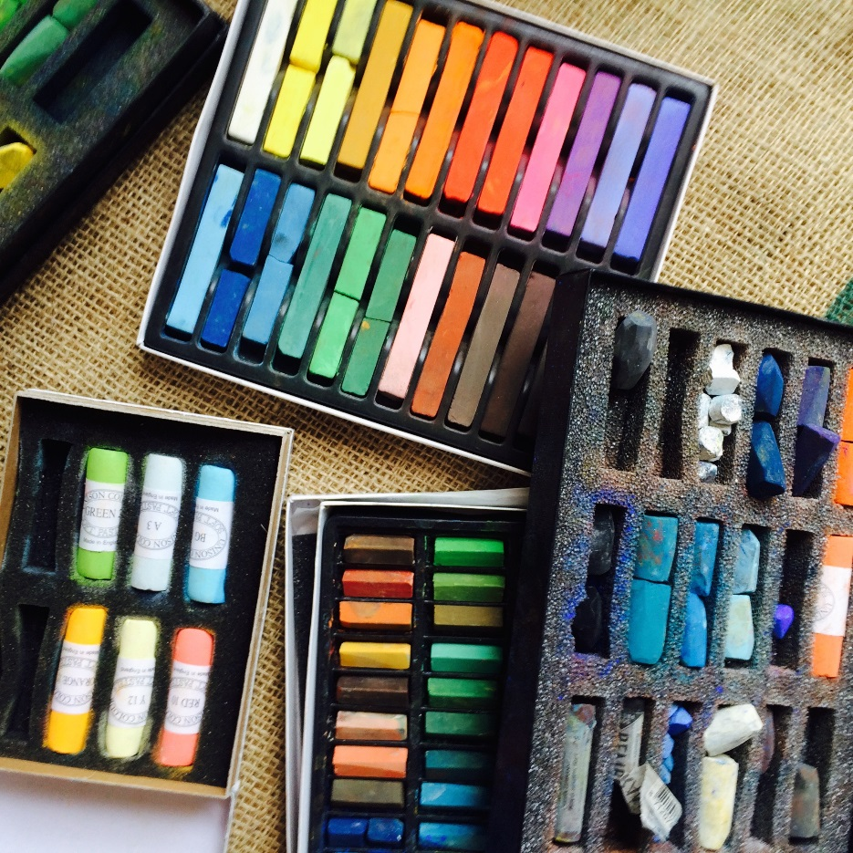
Paint tins:
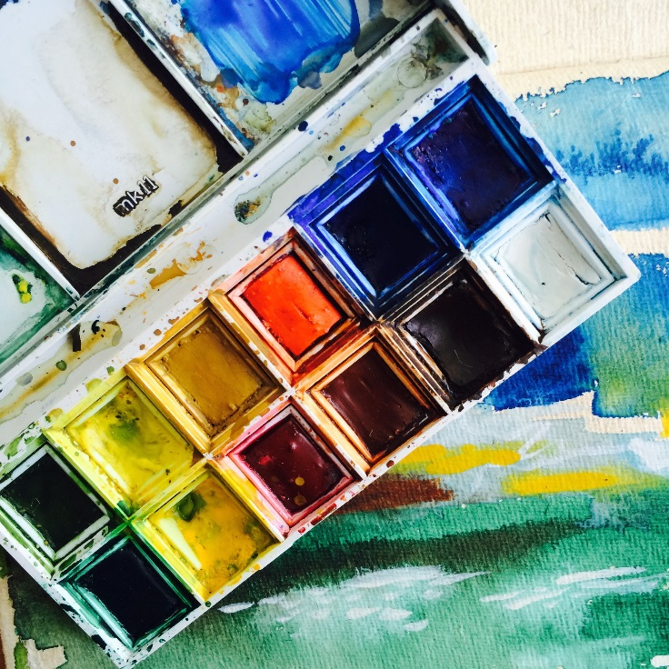
It is good to demonstrate how to use these tins, and how to use then carefully. Children tend to “scrub” them at times, but this pushes the paint tablet into the tin, and make it hard to use for the next person. Children can mix the colours in the lid, or use a plastic mixing tray. When they are finished with the resource, they can be gently cleaned under the tap, and left to dry open, preferably. Washing under the tap can be problematic, as it is easy to “wash” the paint away and waste the colours, so talk about it and show how to do it, so the paint does not wear away.
Oil pastels:
These are very easy and enjoyable to use. They stand a lot of wear and tear, and produce a great effect every time. They invariably get broken, so maybe it is a good ideas to break them in half at first, so that they are still of a good length to use. Encourage the children to put them back in the original boxes, so that the full selection of colours is ready for the next time.
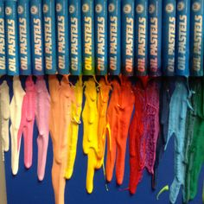
Liquid paint:
This kind of paint is more controllable, and it seems like there is a lot in the bottle. Children need to be taught to not waste it. They tend to over-estimate what they need, and can end up with a puddle of mixed paint, which gets washed down the sink. It is better to take less and then come back for more. The sealed top needs to be put back on after use, so the paint does not dry up.
Children need to be shown how to mix colours effectively, and to progress slowly to the colour they are looking for.
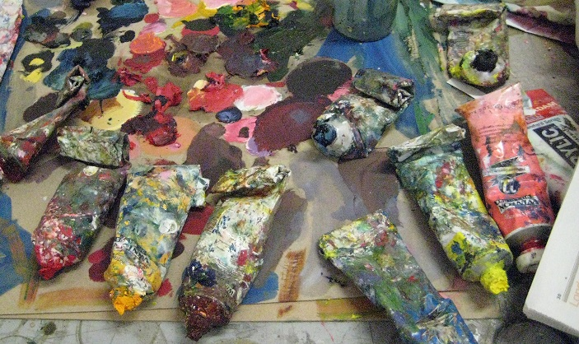

Drawing inks:
Children use these effectively, when the table to set up properly and they are shown how to use the dipping pens and ink, or the use of brushes. The inks must not be mixed in the jars, for obvious reasons. One pen or one brush goes in each pot, and must be kept in that pot. Try to use other things for drawing, like twigs from the tree, straws, cocktail sticks, the list goes on….
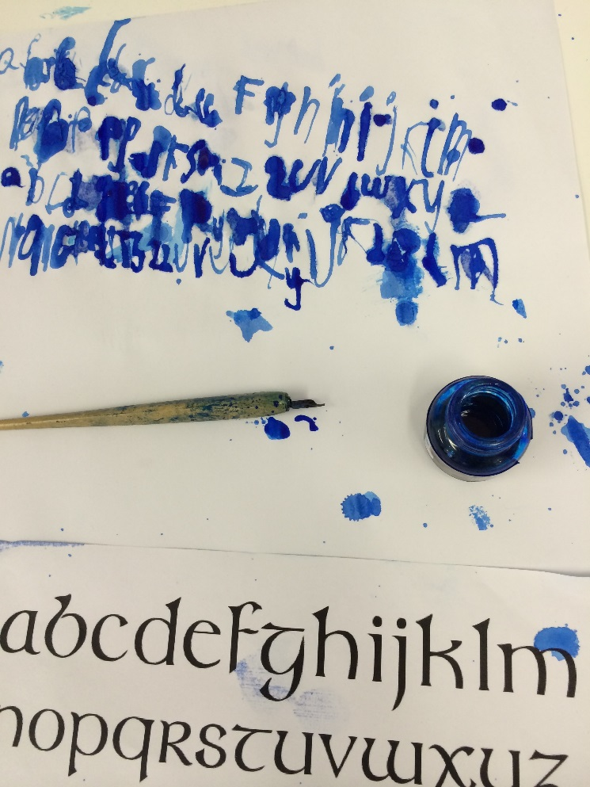
Water pot/mixing trays:
These do not wear out. They look grubby, because they are not cleaned carefully and so residue paint gets mixed in the next colour. It is worthwhile to wash the plastic tools well, and they work better and look better too. If we look after things, then the children get the idea that they are worth respecting and will have a better attitude towards the resources.
